Work

In this work we will see how to create a function in Java. What we are looking at next is the schematic of a simple language in Java.

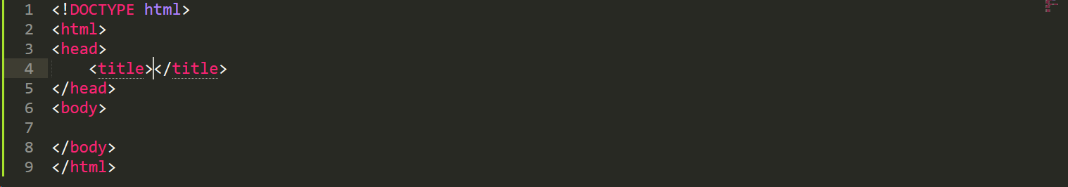

We have to add the Script command, in it we will write the function with all the commands.



In itself this is the name of the function, in this case we want to make a function in which a user enters the value of one side of a square and returns its perimeter.

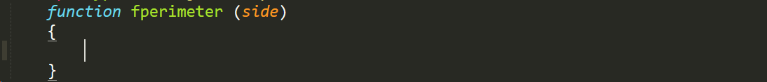  
With this command line, we are declaring ourselves a variable.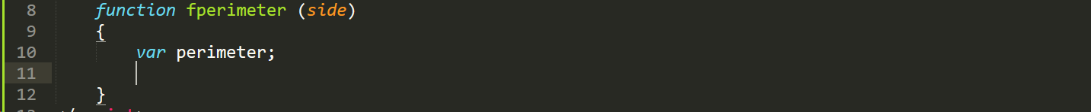

With this line we are telling you not to concatenate the variable and that the perimeter variable is equal to side \* 4.

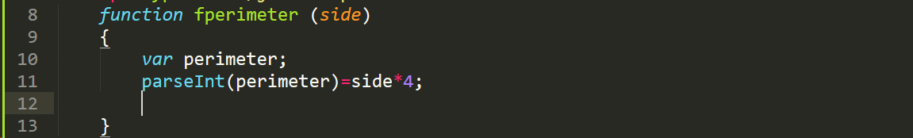

With this command line we are telling it to return the variable, that is, the function, to be able to use if we want to later.

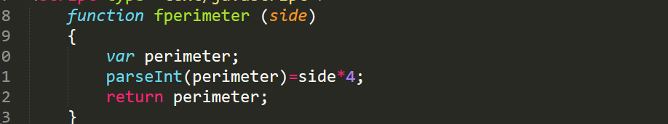

Later we will declare another variable, this will be the side variable.

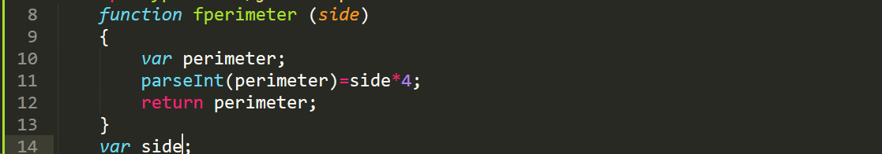

In the next line we are telling the user that we want him to enter the measurement of the side of the square.

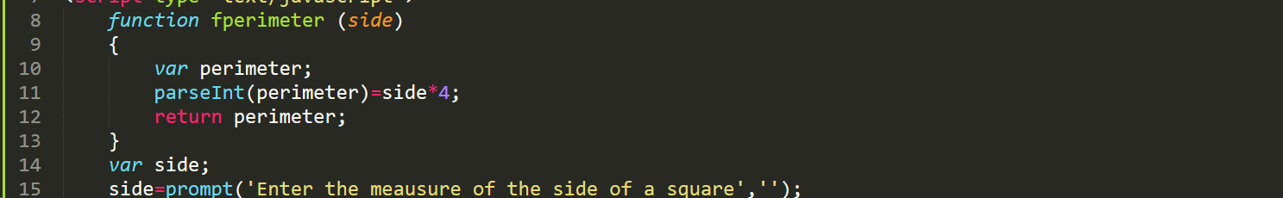

With this line we are telling you that we do not want it to be linked.

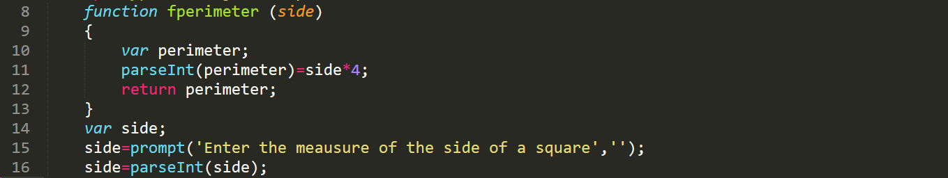

In the last line we are giving you a response message with the perimeter of the side that the user has previously entered.

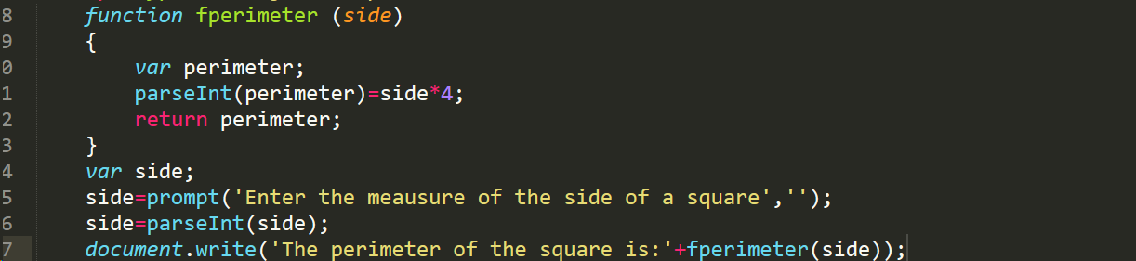

Now that we have everything done, we can run the program. To do this we go to a search engine like Chrome and run it.



In this case we are going to enter the number 5.

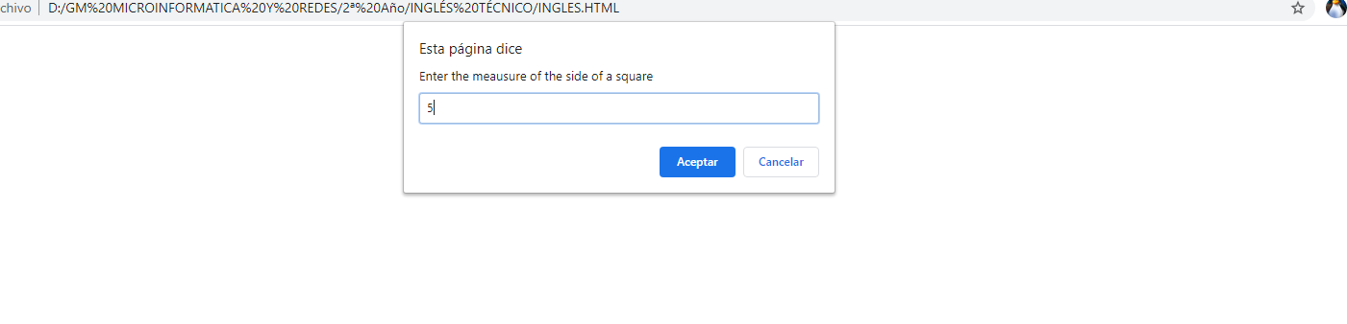

And it will give us its perimeter as a result.